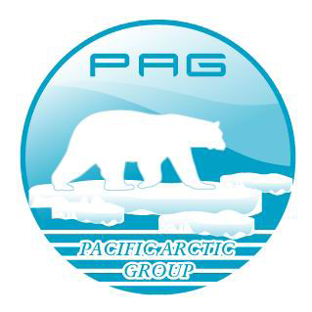 | Pacific Arctic Group (PAG) Fall Meeting  Agenda  October 28-29, 2015  Korea Polar Research Institute (KOPRI)  26 Songdomirae-ro, Yeonsoo-gu  Incheon 21990, Republic of Korea | 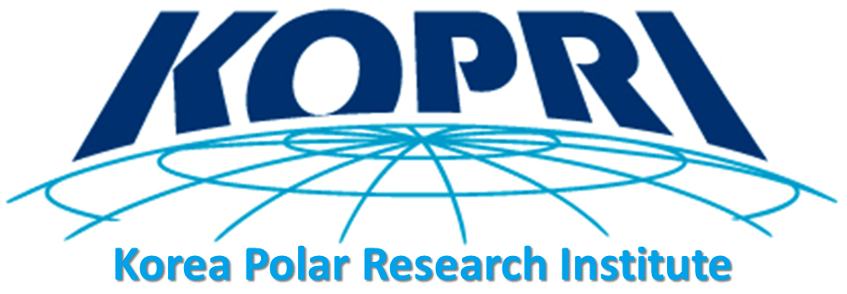

*meeting agenda, presentations and final report will be posted on the PAG website http://pag.arcticportal.org/

Wed. October 28, 2015 | Thur. October 29, 2015
0830 and 0930 - transport hotel to KOPRI (van ride); security clearance and registration | 0900 and 0930 transport hotel to KOPRI (van ride)
0930 ‐ 1030 Morning 1 | 0930 ‐ 1030 Morning 1
1030 ‐ 1050 Coffee break | 1030 ‐ 1050 Coffee break
1050 ‐ 1230 Morning 2 | 1050 ‐ 1200 Morning 2
1230 ‐ 1400 Lunch at KOPRI (KOPRI tour) | 1200 End of PAG meeting; van rides to restaurant
1400 ‐ 1530 Afternoon 1 | 1230-1400 Lunch hosted by KOPRI
1530 ‐ 1550 Coffee break | 1400 – Van rides to hotels
1550 - 1720 Afternoon 2
1730 - Van rides to restaurant
1800-2000 – Dinner hosted by KOPRI
2000 – Van rides to hotels

Overview: The Fall PAG meeting is hosted at various locations in alternating PAG countries after the field season and is focused on review of accomplishments during the previous summer and outlooks for the future. The fall 2015 PAG meeting (1.5 days) will be held at the KOPRI (Korea Polar Research Institute). The annual fall meeting will provide country updates on 2015 field activities and results, status reports on the developing Pacific Arctic Climate Ecosystem Observatory (PACEO) and shelf-basin exchange lines, sea ice studies, the Distributed Biological Observatory (DBO), and ongoing synthesis activities. These discussions are useful in developing scientific exchanges and other types of collaborations during and after field operations. The Spring PAG meetings are held during Arctic Science Summit Week and are focused on “business” issues and an update on research plans for the coming field season.

2015 Fall PAG Meeting: 28 October 09:30 start time at KOPRI (see schedule above)

Introduction and Welcome (Sung-Ho Kang)
- Welcoming remarks (Yeadong Kim, KOPRI President)
- Brief introduction of PAG and meeting agenda (Sung-Ho Kang, Chair)
Agenda items:

- Update (highlights) of 2015 field results and science findings; preliminary 2016 plans (up to 30 minute maximum time per country, including discussion)
  - Canada: TBD
  - China: Jianfeng He/Jinping Zhao
  - Japan: Takashi Kikuchi/Shigeto Nishino
  - Korea: Eun Jin Yang
  - Russia: Vladimir Ivanov
  - United States: Jackie Grebmeier

- Updates and Planning of PAG joint field and modeling activities
  - Chukchi Borderland/Arctic Basin joint activities
- RUSALCA northern expansion program shelf to basin (Aleksey Ostrovskiy)
- CB/Basin and shelf-basin exchange lines (Bob Pickart, Takashi Kikuchi, Koji Shimada)
- NABOS update (Vladimir Ivanov, Igor Polyakov)
  - Ecosystem (Jackie Grebmeier, Takashi Kikuchi)
  - Satellite observations (Josefino Comiso, Hyun-cheol Kim, Hirawake Toru)
  - Long-term planning for Joint Program Scientific Research and Monitoring in the central Arctic Ocean and adjacent shelf areas (Phil Mundy)
  - Sea ice and atmosphere (Joo-Hong Kim, Jun Inoue)
  - Modeling activities (Jia Wang, Baek-Min Kim)
  - Coordinating mooring locations (Phyllis Stabeno-presented by Jackie Grebmeier, Kyoung-Ho Cho, Koji Shimada)
  - Other PAG relevant activities-open discussion

- Status report on PAG-endorsed DBO and PACEO ongoing and planned future activities (Jackie Grebmeier-session lead, with results from others beyond presented in country reports)
  - Brief highlight science findings from the DBO pilot program 2010-2015
  - The new DBO lines in the Beaufort Sea, pending extension of DBO4 in the NW Chukchi Sea, update on DBO-type lines in the Northern Barents Sea
  - DBO EOL archive and AXIOM workspace, DBO and PAG metadata policy
  - Plans for 2016 field activities and DBO publications
  - Results from pilot PACEO in 2015 and plans for PACEO 2016 field activities
    - Physical oceanography and sea ice dynamics (Vladimir Ivanov, Koji Shimada, Jinping Zhao, Kyoung-Ho Cho, Ho Kyung Ha)
    - Chemical oceanography (Jessica Cross, Tae Siek Rhee, Jin-young Jung, Sun-Yong Ha)
    - Biogeochemical oceanography (Sang Lee, Kyung-Hoon Shin, Naomi Harada)
    - Ecosystem (Jackie Grebmeier, Eun Jin Yang, Hyoung Sul La)
    - Sediment trap (Naomi Harada, Dong-sun Kim)
    - Atmosphere and sea ice (Joo-Hong Kim, Jun Inoue)
    - Satellite observations (Josefino Comiso, Hyun-cheol Kim, Hirawake Toru)
    - Modelling (Baek-Min Kim, Jia Wang)

- Data sharing and issues-discussion
- Discuss DBO/PAG data policy in relation to IASC data policy (Jackie Grebmeier)
- PAG Web-GIS for data sharing (Junhwa Chi)
- Other input?

5. Synthesis-status and future plans
  - Biogeosciences-special issue update (Takashi Kikuchi)
  - ARAON DSR Special issue update (Sang Lee)-completed
  - DBO special issue (Jackie Grebmeier)
  - Ideas for other synthesis products?

- Updates on interactions with other organizations and upcoming meetings – AFoPS, IASC, SAON, PICES, APECS, others
  - CAFF/PAME/AMAP activities (Phil Mundy)
  - AFoPS activities (Hyoung Chul Shin)
  - Arctic Observing Open Science Meeting, November 2015 (Kyoung-Ho Cho)
  - North Pacific Research Board Arctic call (Danielle Dickson)
  - Gordon Research Conference/Seminar, March 2017, CA (Jackie Grebmeier)
  - ASSW 2017 Science Symposium (Takashi Kikuchi, SSC of the ASSW 2017)
  - Others?

- PAG structure
  - Executive committee composed of PAG Chair, Vice-Chairs, and leads from each of PAG activities: DBO (Jackie Grebmeier), Canada Basin, PACEO (Koji Shimada), sea ice-atmosphere (Joo-Hong Kim)
  - Current rotation plan: Chair and Secretariat
    - 2014-2016 – Korea (Sung-Ho Kang, KOPRI)
    - 2016-2018 – Japan (TBD)
    - 2018-2020 – Russia, Canada, or China?

- Future PAG meetings:
  - March 12-18 2016 – ASSW2016, Fairbanks, Alaska (https://assw2016.org/)
- (PAG meeting March 13, 2016)
  - Fall 2016 – Qingdao, China
  - Spring 2017 - ASSW2017, Prague, Czech Republic
  - Fall 2017 – TBD (Tokyo, Japan?)
  - June 2018 - ASSW2018, Davos, Switzerland

